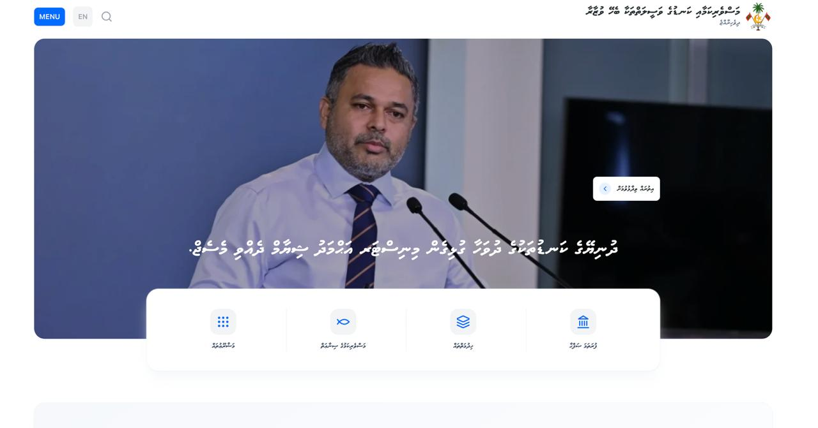

**1. Font Size Adjustment**

**Issue:** The current font size is too large and covers/overlaps with images.

**Suggestion:** Reduce the font size to ensure proper visibility of images and maintain visual balance.

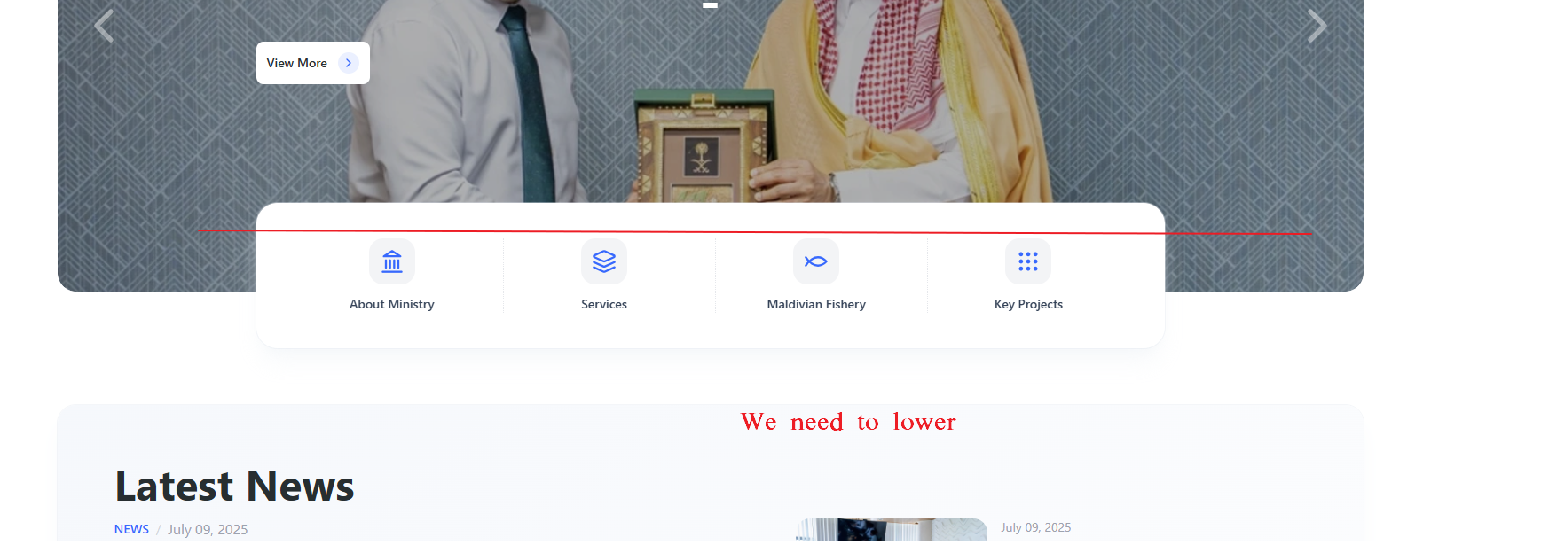

**2. Navigation Section Positioning**

**Issue: -** We need adjust the position of the navigation section (About Ministry, Services, Maldivian Fishery, Key Projects) shown in the attached screenshot.

* we need to lower it a bit so that it doesn’t overlap with the slider/banner area above.
* The red line in the image indicates the estimated ( 1 inch) . This adjustment will improve the visual balance and picture

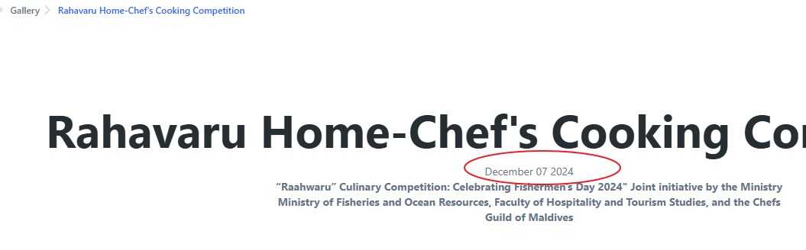

**Date Correction**

**Issue:** Incorrect date display **Suggestion:** Update the date to December 07, 2024

**Event Page**

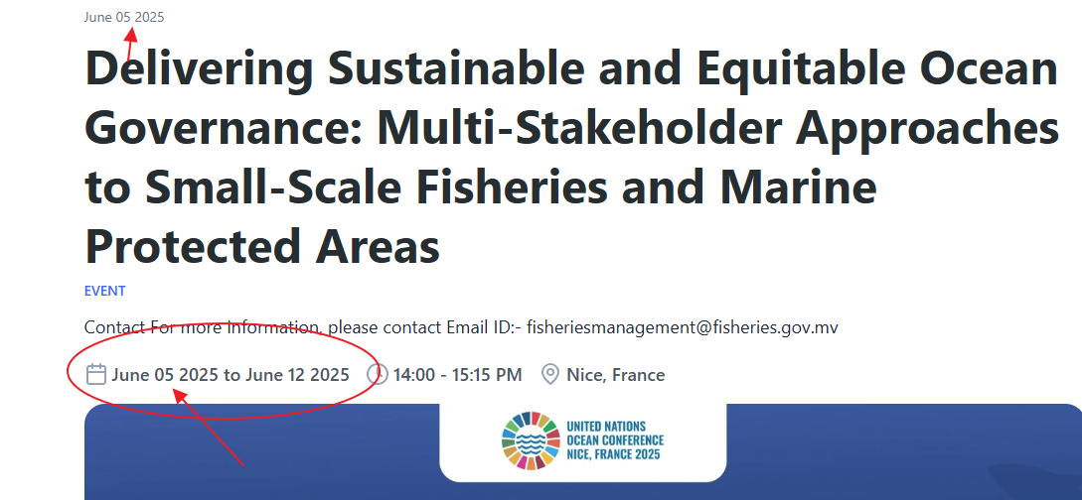

**Event Page - Job Announcements Display Issue**

**Issue:** Job announcements published under Projects → Jobs in the CMS are not displaying on the Home Page.

Eg:- we published on (16th June 2025).

**Need to check the technical error :** Determine if this is caused by publication date settings or display filter configurations

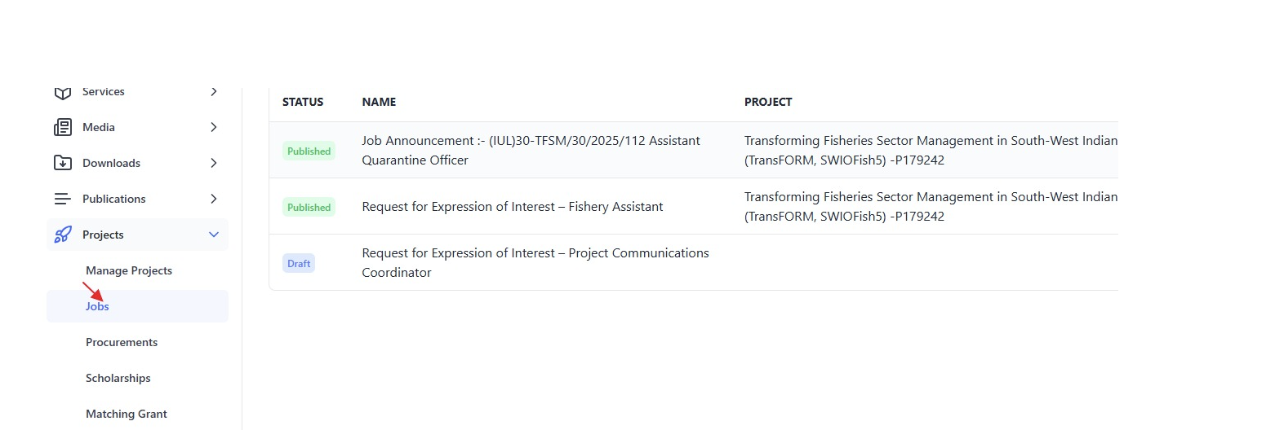

* އިތުރަށް ބެލުމަށް (typo mistake (

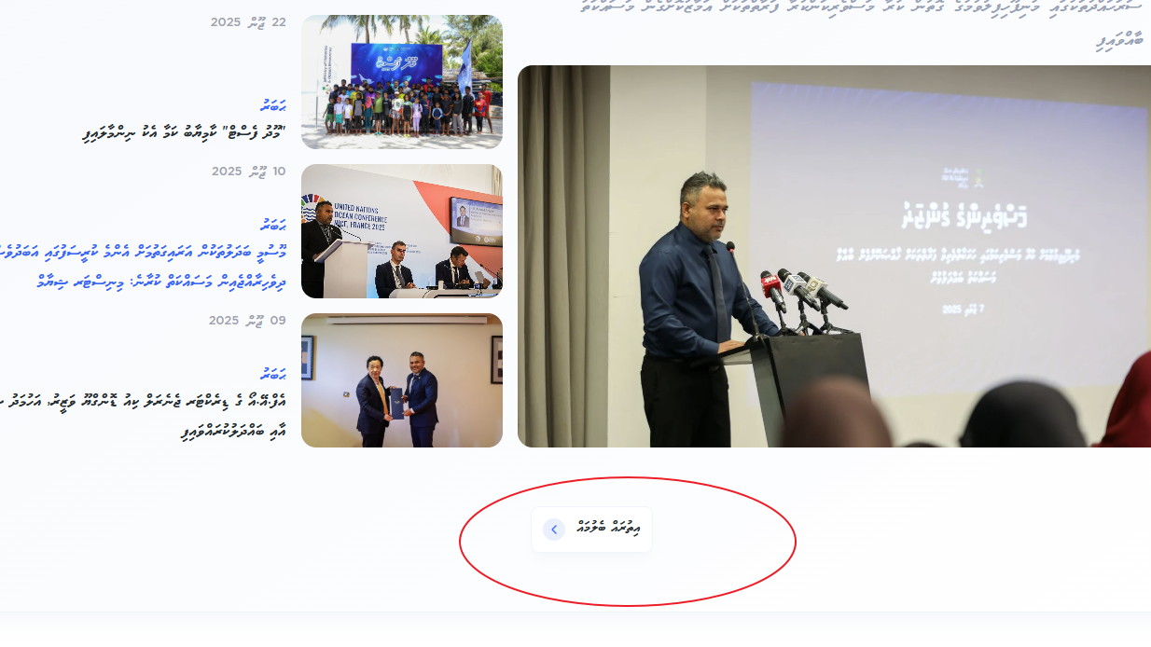

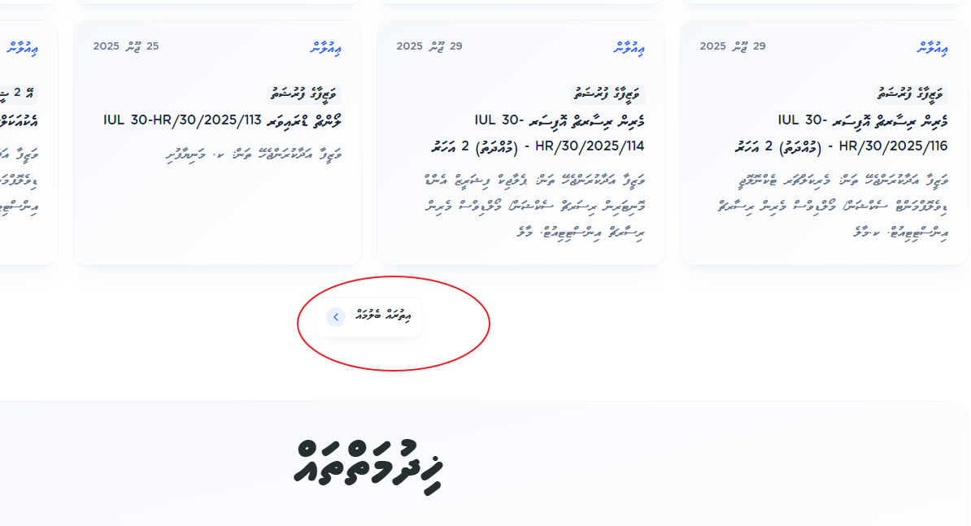

**Email Functionality**

**Issue:** Inquiry email functionality is not working. **Suggestion:** need to test from the code side

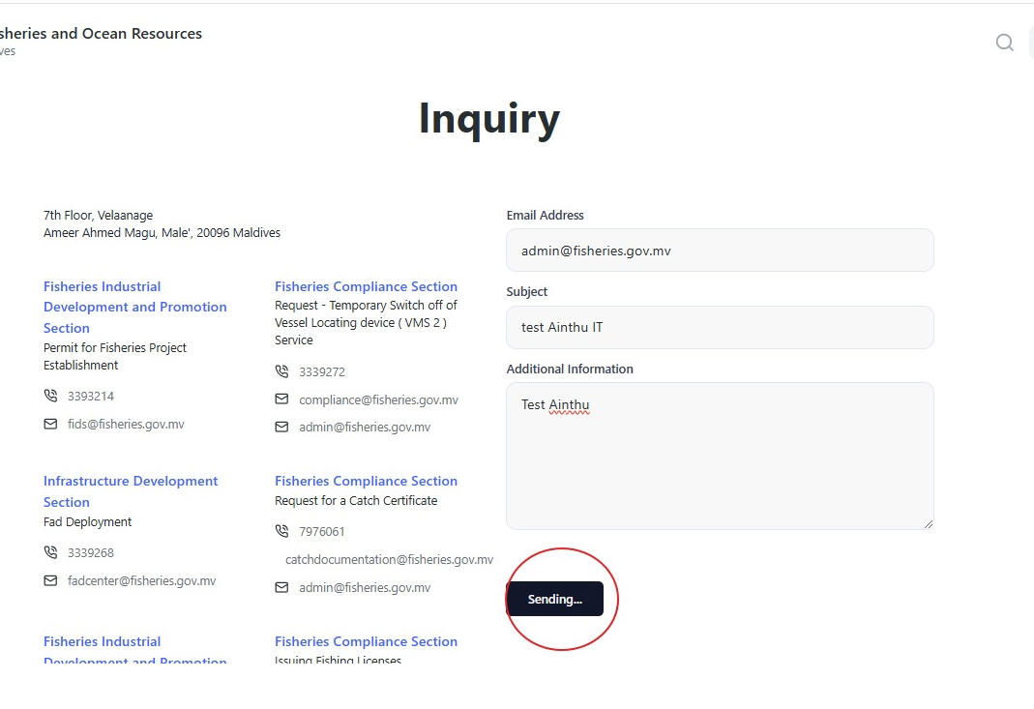

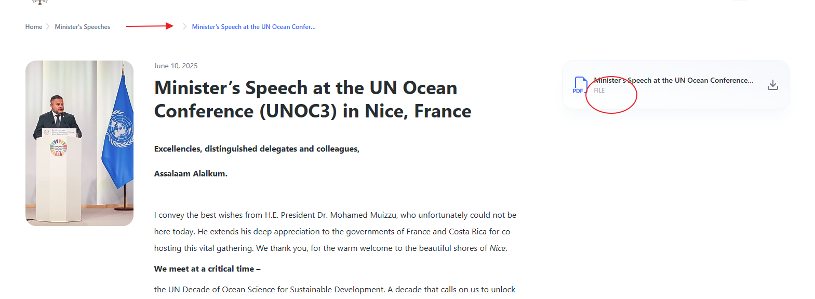

**Download File Display Issues**

**Issues:**

* Download file size is not visible on Minister Speech download files (both Dhivehi and English sections)
* Excessive vertical spacing between breadcrumb ("Minister's Speech at the UN Ocean Conference...") and heading

**Suggestion**: - The current vertical spacing between the breadcrumb (Minister’s Speech at the UN Ocean Conference…') and the heading is too much space. We recommend to reduce the vertical space between them for better visual alignment.

(Same Issues)

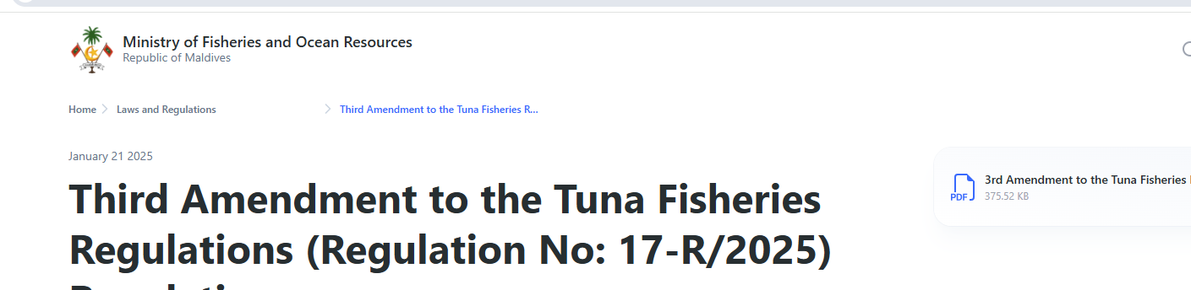

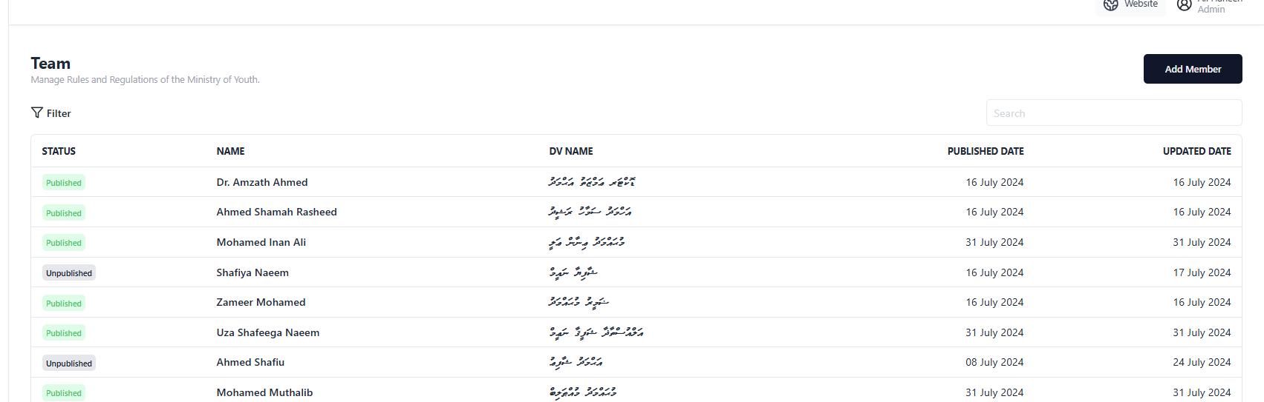

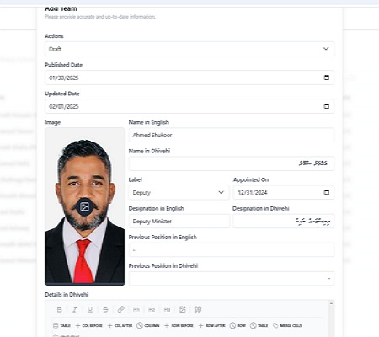

**Issue;** - Currently, the "Add Team" section only allows users to input Senior Staff & political appointees details. When user entered data, but after submission, its data is not being saved to the CMS panel and does not appear on the homepage.

**Suggestion**: - Basically need to, Fix the backend-frontend connection to ensure data persistence and display

**Issues noted under the Project page – Job Announcement module:**

* Job announcements uploaded through CMS panel do not appear on the project page homepage
* Announcements are not displaying in the "Announcements" section on the main homepage.

Suggestion: Fix the display mechanism for job announcements on both locations.

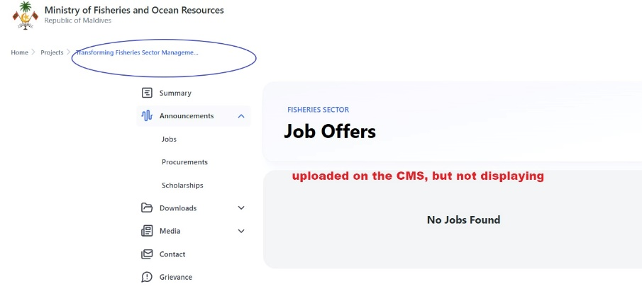

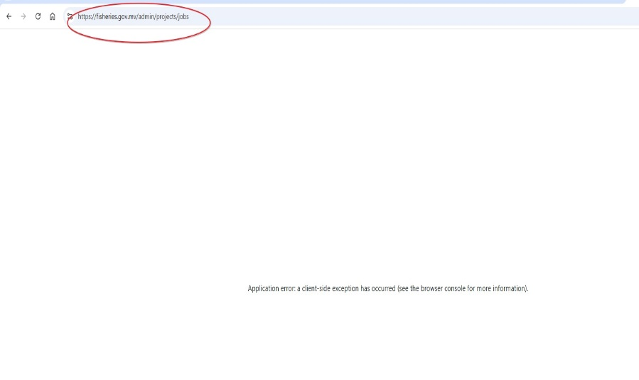

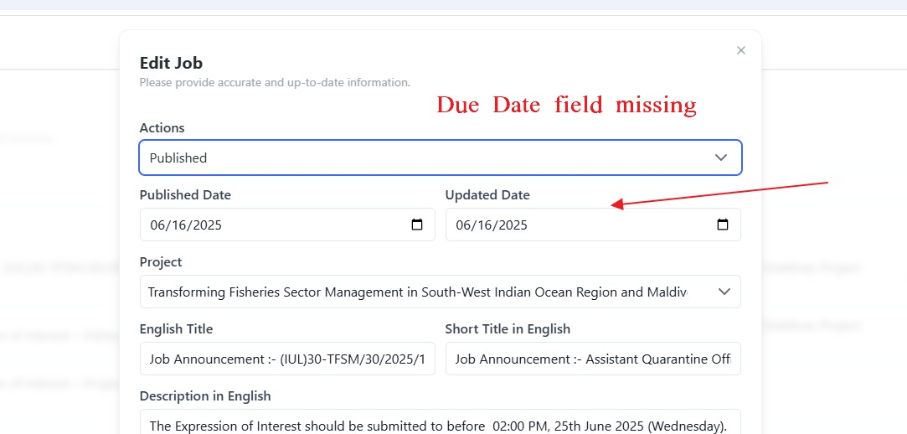

**Issue:** Due dates are not being displayed

Suggestion: - Implement proper due date display functionality

*

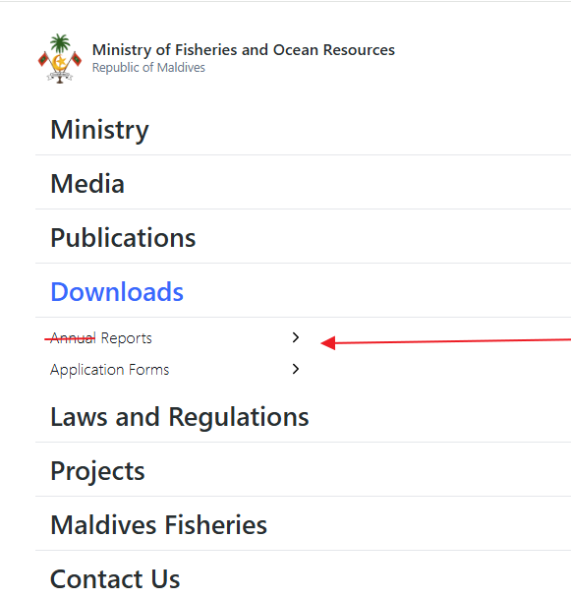

**Menu Structure Changes**

* Change existing menu name to "Reports" and add associated page
* Add new menu item: "FAQ / އާންމު ސުވަލާއި ޖަވާބު"

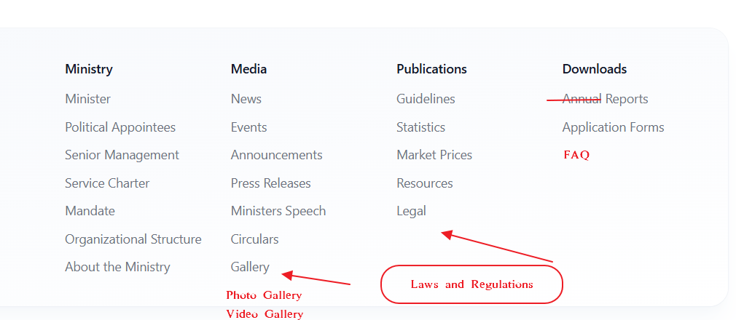

**Quick Links Updates**

**Suggestion:**

1. Add FAQ to quick links
2. Change "Legal" to "Laws and Regulations"
3. Change "Annual" to "Report Only"
4. Modify "Gallery" to include:
   * Photo Gallery
   * Video Gallery

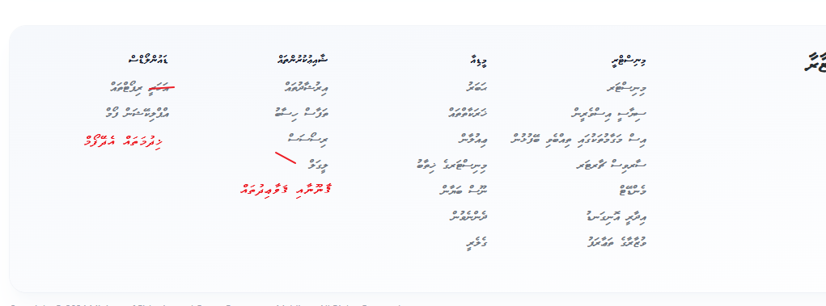

Suggestion.

* Application form: Display as "ޚިދުމަތައް އެދޭފޯމް"
* Gallery links:
  + Photo Gallery: "ފޮޓޯ ގެލަރީ"
  + Video Gallery: "ވީޑިއޯ ގެލަރީ"

Increase heading font size by one level

FAQ Section (Dhivehi)

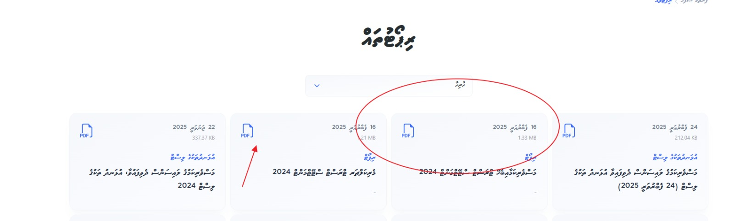

**Issue:** Document file sizes are not displayed next to documents

**Suggestion:** We need the size of the document to display near the document. ( Both in English and Dhivehi)

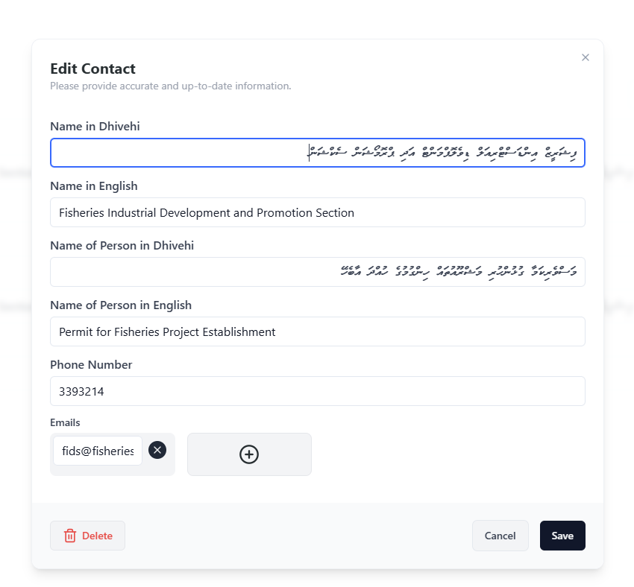

**Unpublish Functionality**

**Issue:** Missing unpublish function/field

**Suggestion:** Add unpublish functionality to the CMS

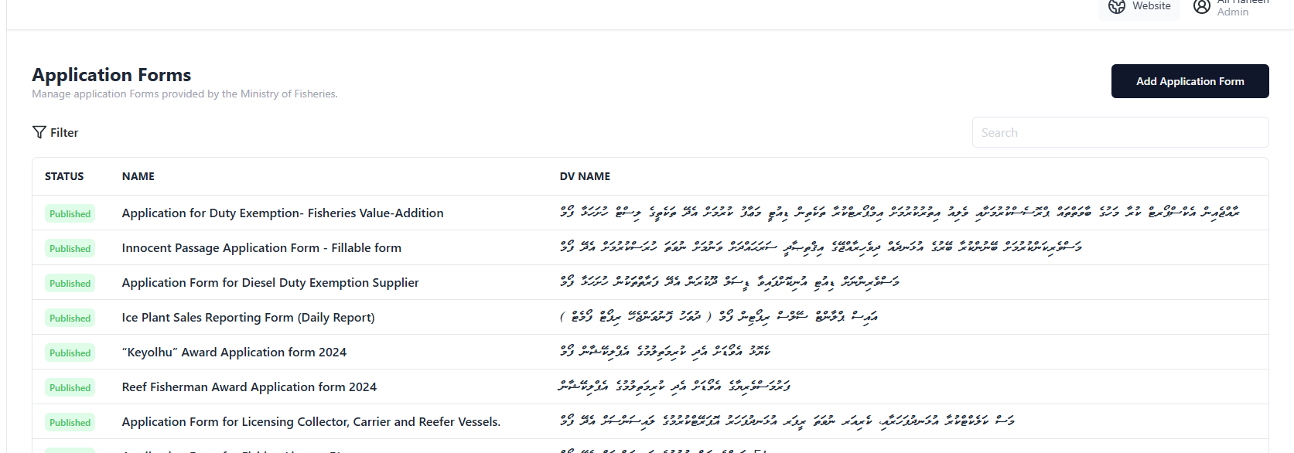

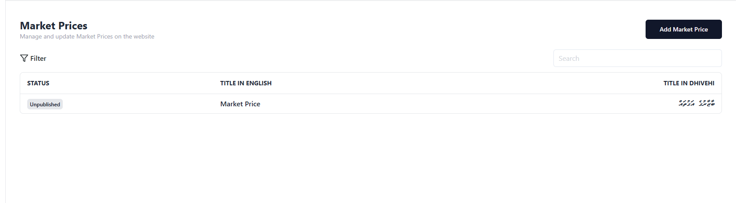

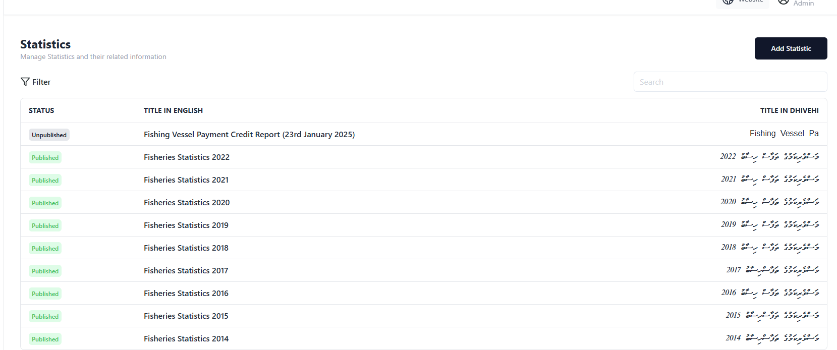

**Date Fields for Content Management**

**Suggestion:** Add "Published Date" and "Update Date" fields to the following pages in the CMS panel:

* Statistics
* Market Price
* Application Form

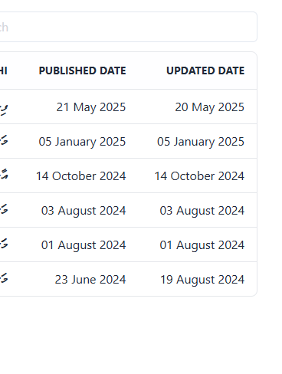

**Application Form_ Title Display**

**Issue:** When users add application form titles, Dhivehi and English text do not display properly **. Suggestion:** Fix the multilingual display functionality for application form titles

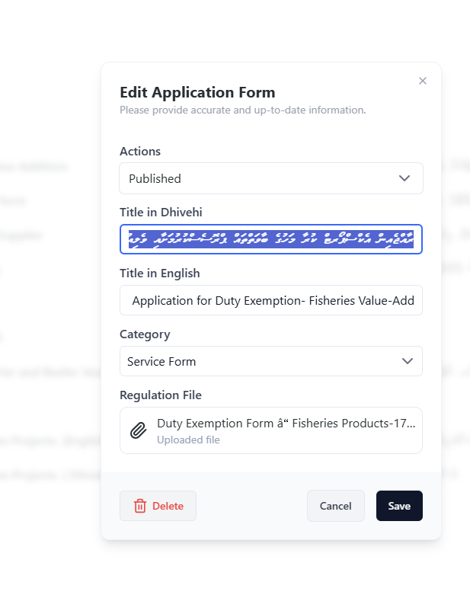

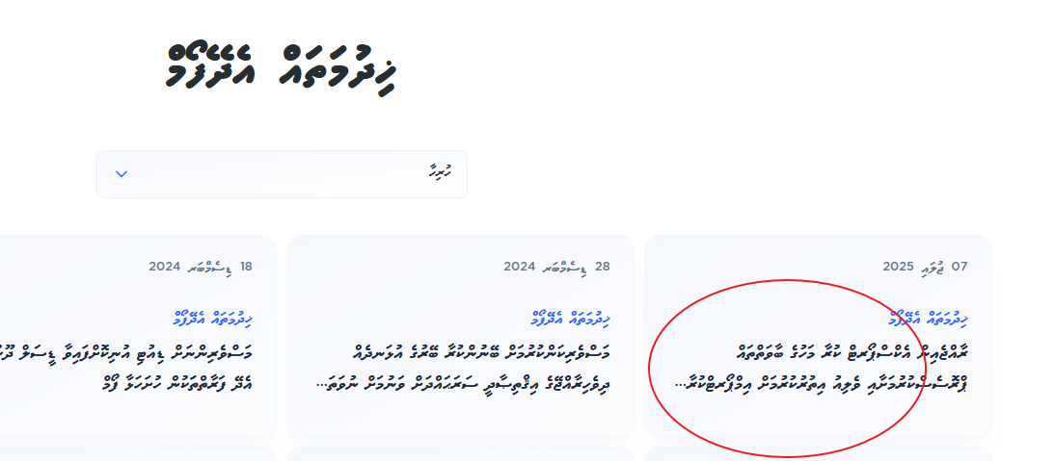

**Overall main Issues of the website.**

1. Navigation and display issues.
2. Backend-frontend connectivity problems.
3. Content management and publishing functionality
4. Multilingual support improvements.